Comedy Styles in the Play

As with all of their productions, the playwrights have drawn on numerous comedy styles in creating The Complete History of America (abridged). The time during which they grew up (they are of the Boomer Generation) proved to be a fertile one for aspiring comics, presenting numerous sources and styles. A few of those are noted below.
Vaudeville

Much of the structure and many of the bits in Complete History of America (abridged) derive inspiration from the American form of entertainment known as “vaudeville.” While vaudeville affected American culture most widely between the 1870s and the 1920s (coincidentally the very era that the playwrights slight in the play!), its various styles of comedy continued well after the 1920s to infuse the new technologies of the radio and television. Multiple acts, from acrobats to comedians to animals, stepped upon the vaudeville stage before mostly middle-class audiences.

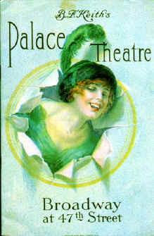
The program cover for Keith's Palace Theater in New York City, the most desired booking in all vaudeville.

Clown

The playwrights have some “clown” background (in training and/or in respect for previous clowns). The clown has had much cultural influence and interaction from the beginning of humankind. In addition to the physical aspects of this production, the key connection to “clown” is the place the clown holds within society—at a point where s/he is able to satirize and to reveal truths that others might not.

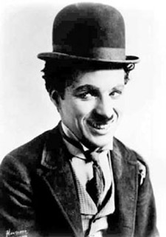Charley Chaplin

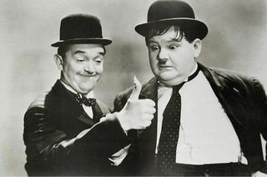

Laurel and Hardy, in a promotional still from their 1937 feature film Way Out West.

Black Comedy

Some scenes in the play (e.g., the Lincoln assassination done in a ballet format with the character of Lincoln presented in Baraku Puppet suit) reflect a form of “black comedy.” This form of humor embraces stories and issues, such as illness, war, and murder in ways (sarcasm, sardonic humor) that reveal insights that escape everyday analyses. Pop culture examples include the films Dr. Strangelove (1964), Prizzi’s Honor (1985), and Fargo (1996), and the newspaper The Onion, and Jon Stewart’s faux news presentations on The Daily Show.

Farce

This style embraces fast-paced comedy that often increases speed through a scene and involves a chase. Unlikely events, mistaken identities, puns, innuendos, absurdity and nonsense often join broad, physical humor in this comedy style. “I Love Lucy” (which inspired a character in the play!) comes to mind.

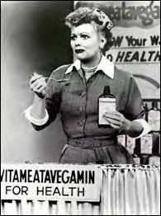

Lucille Ball in “I Love Lucy”

Satire

Satire utilizes (hides behind?) humor to criticize an individual, a group, or an idea. The playwrights maintain, however, that the cheap laugh—not social commentary—drives their comedy. Still, they admit late in the play that much of what they have presented is cynical …. You decide.

